# Chapter 2

**Literature review**

## 

## Introduction

Since this project is based on building a new system, we will be examining an existing system and try to find its drawbacks. The reason behind this review is to find better and faster solutions for problems to apply it to the new system.

## Nazeel Management System

Nazeel is an online management system for hotels. The system consists of the following:

### Login page

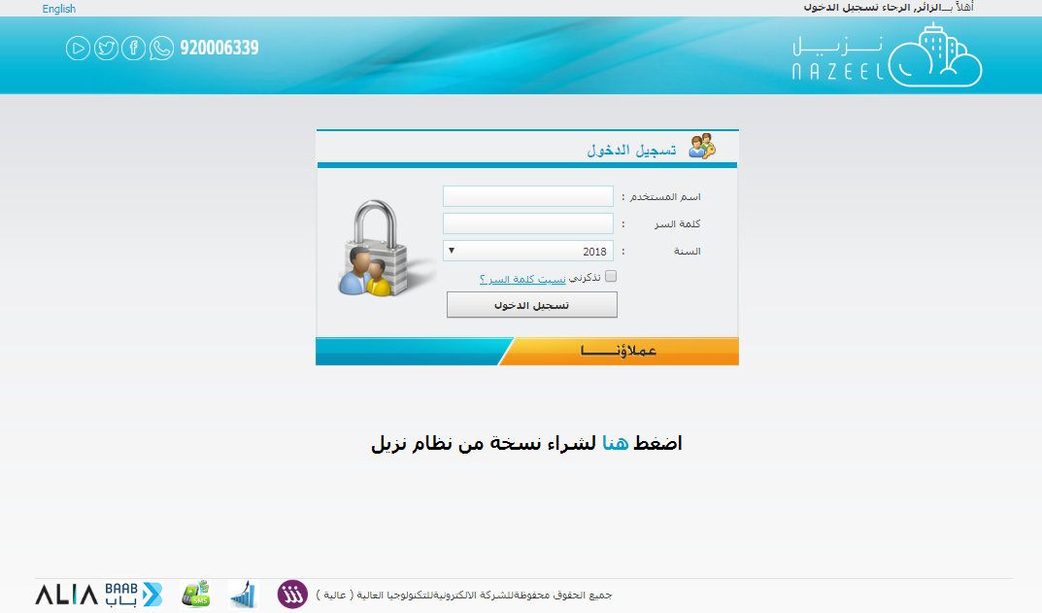

### Main page

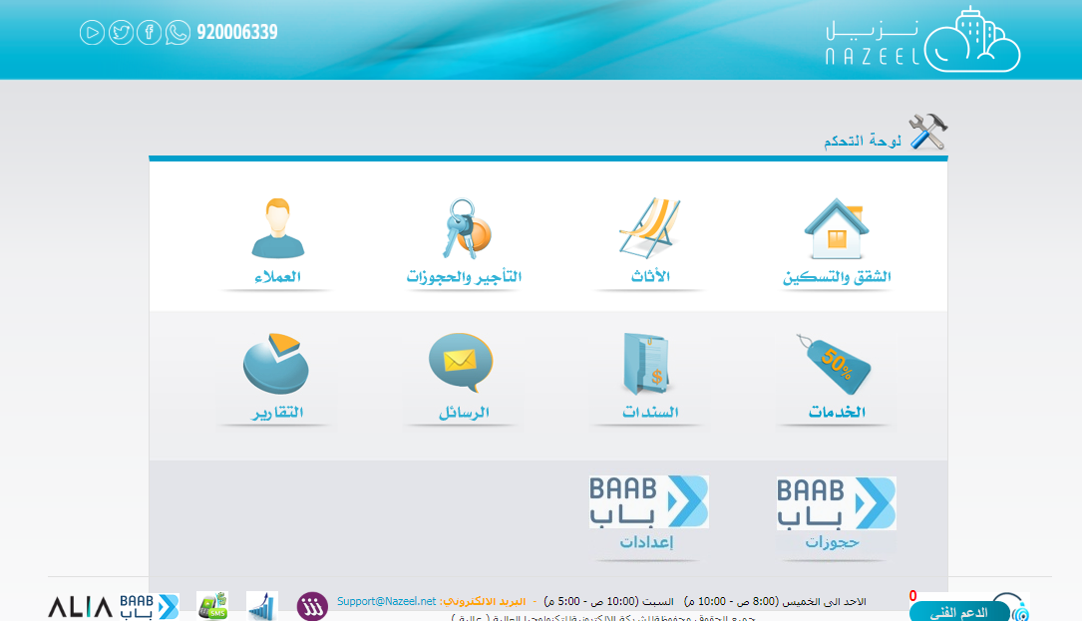

### Reservations

This system allows hotels to:

* Show the admin the available rooms in order to check in.
* Show the admin the rented rooms in order to check out.
* Allows admin to change the states of the rooms.

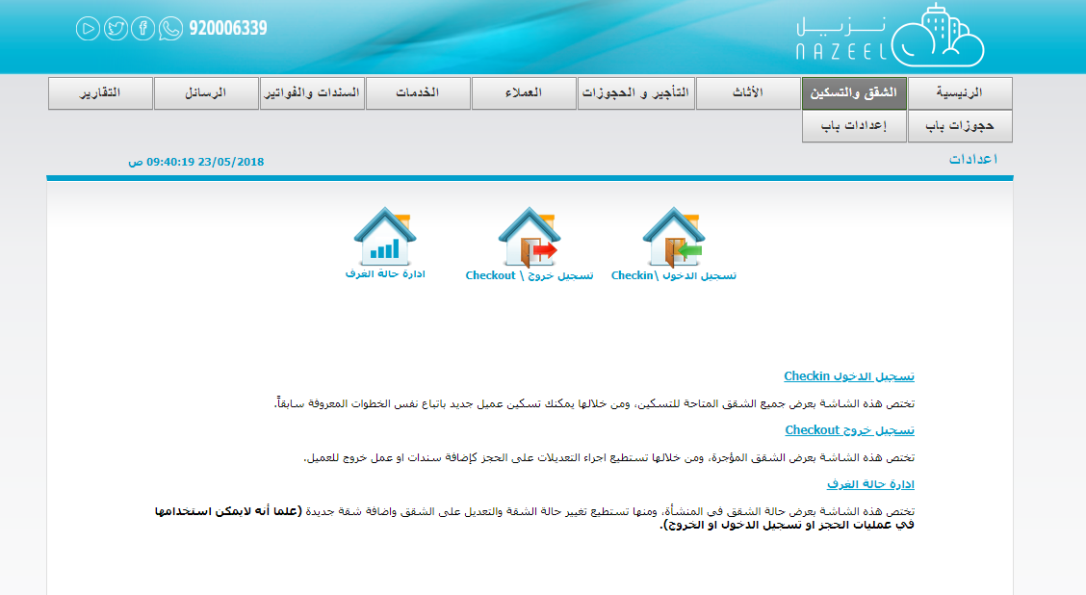

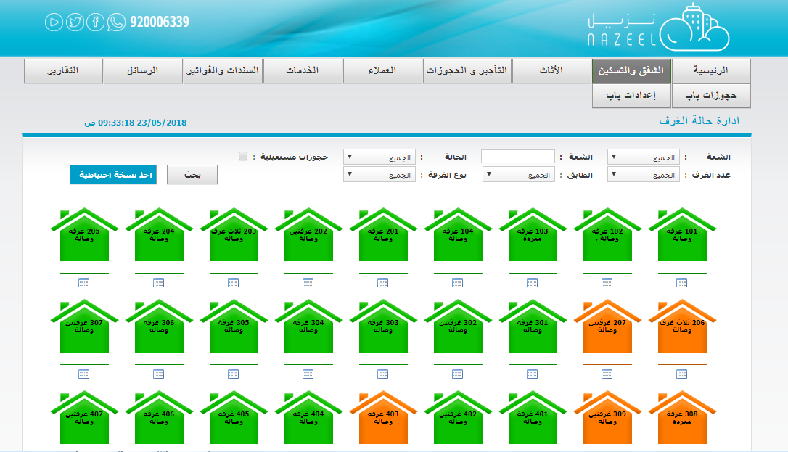

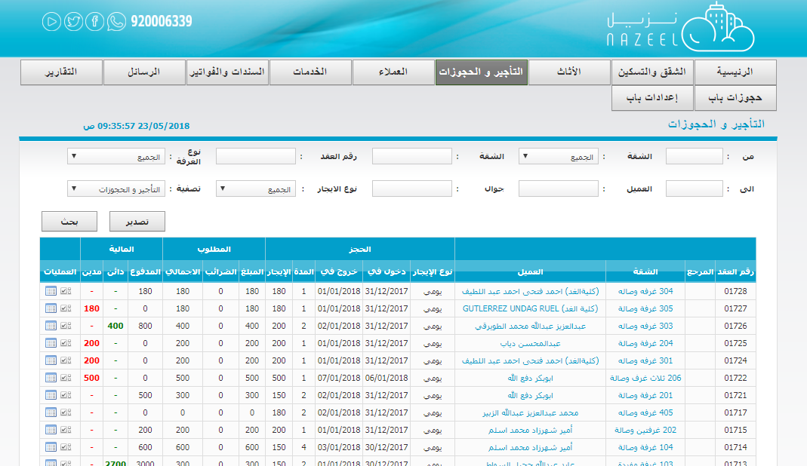

### Furniture

The system allows furniture tracking for each room inside the hotel. The user can add, modify or remove any peace of a furniture.

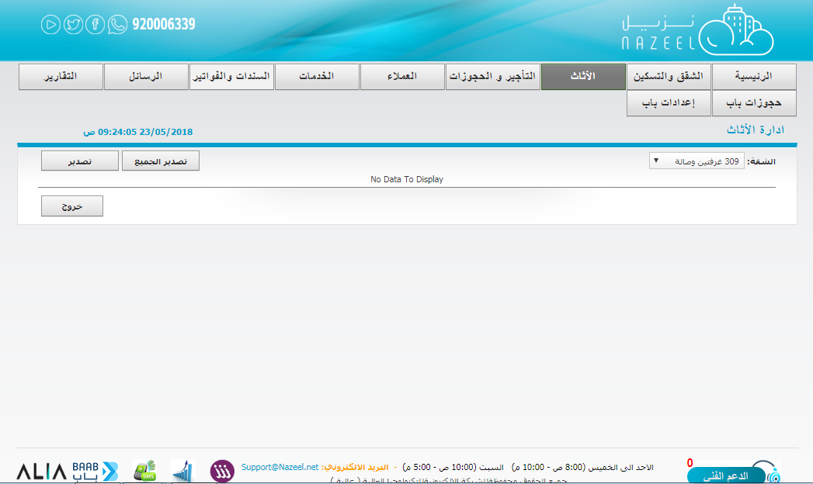

### Customers

The system has a customer’s module to manage new or existing customers.

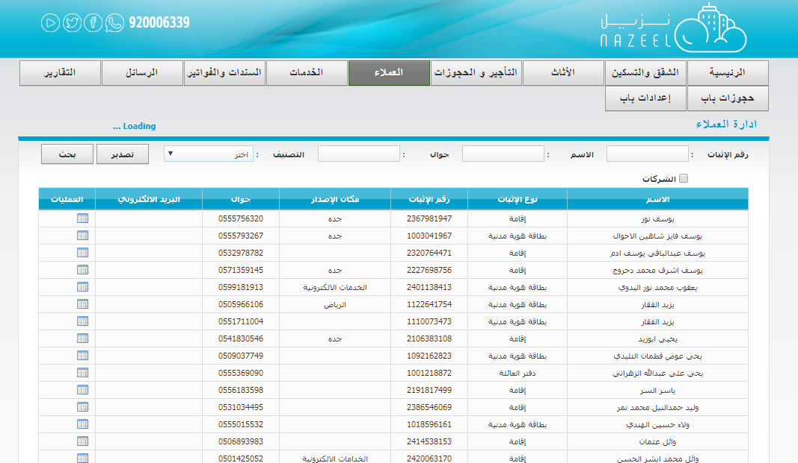

### Services

The system allows admin to order some services and the system will automatically add the charge to the bill of a certain resident.

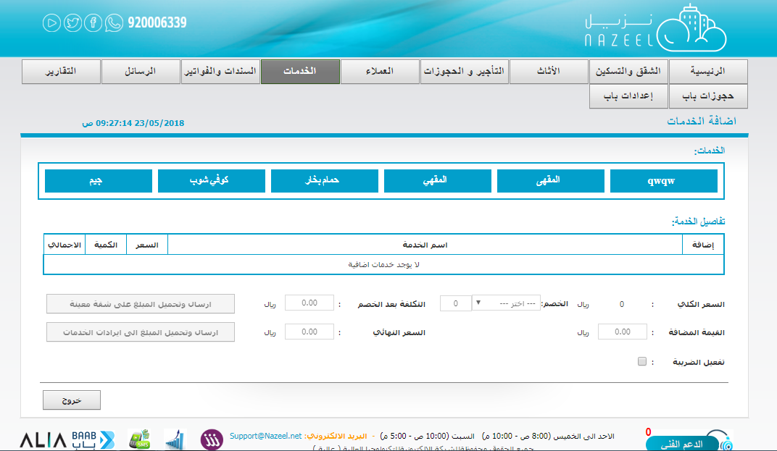

### Bills

The system has an entire billing module:

* Exchange Bonds
* Banknotes
* Services
* Receipts

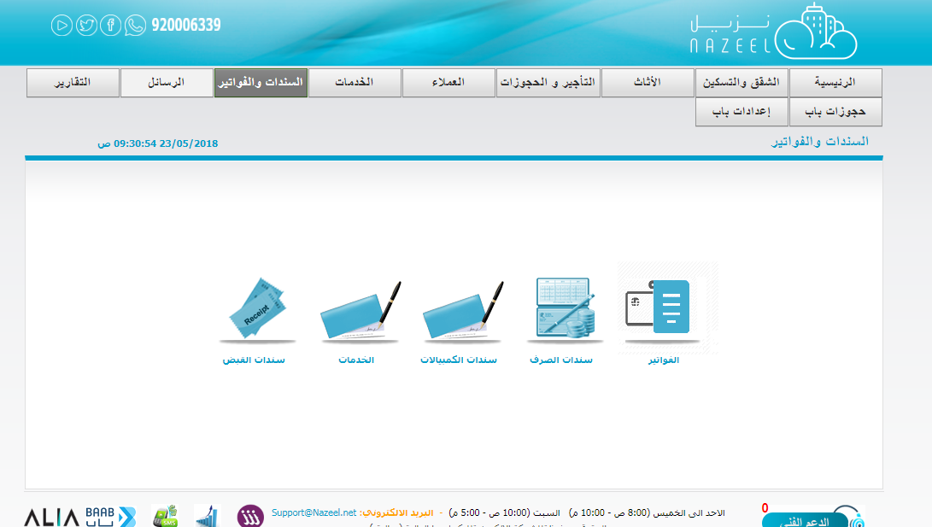

### SMS

The system is integrated with a third-party SMS provider to allow hotels to use the service for their customer.

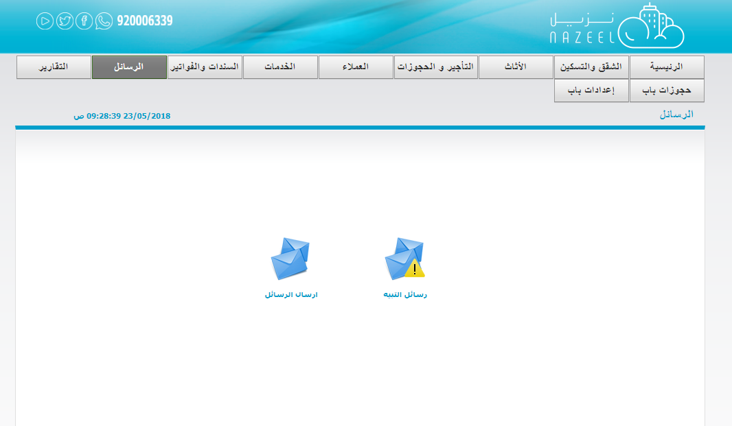

### Reports

The system provides the following reports:

* Total monthly report.
* Bills Report.
* Customer Report.
* Message summary report.
* Reservations report.
* Services report.

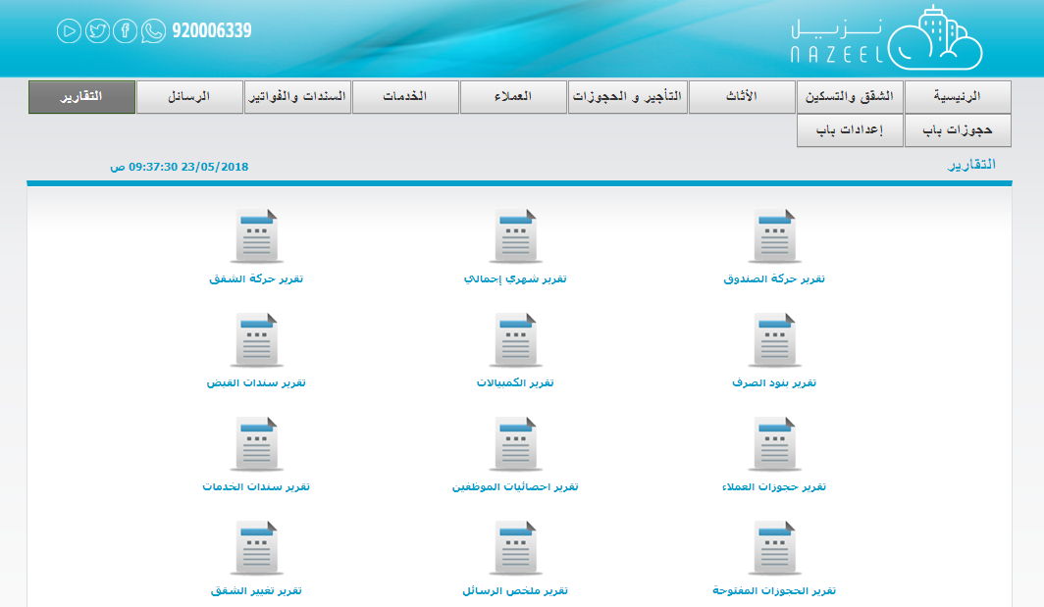

## Features

* The system is easy to use.
* The system is easy to get.
* The system is cheap.
* The system is has SMS service.
* The system is has a lot of reports.
* The system is has bills module.

## Defects

* The system is not has a good designed.
* The system is not has purchases module.
* The system is not has a complete services module.